CENTRAL TEXAS ALLERGY & ASTHMA
Priyanka Gupta, M.D.
www.CTxAA.com

Keratosis Pilaris

Keratosis pilaris is a common autosomal dominant, genetic follicular condition that is manifested by the appearance of rough, slightly red, bumps on the skin. Keratosis pilaris has no long-term health implications.

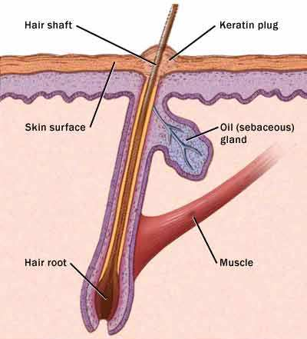
Who does Keratosis Pilaris affect?
Keratosis pilaris affects an estimated 50% of the adult population and 80% of adolescents. It is more common in women than men and is often present in otherwise healthy individuals. This skin condition is prevalent in all races and can manifest in all ages. Most cases appear in the first decade of life and are more common in young children. In most cases the condition gradually improves before age 30, but can persist longer.

What causes Keratosis Pilaris?
The human body produces a natural protein in the body called keratin. Keratosis Pilaris occurs when the body produces too much of the keratin and it surrounds and entraps the hair follicles in the pore. Many of the bumps from this skin condition contain an ingrown hair that has coiled. This prevents the hair from exiting and it grows encapsulated inside of the follicle.

Signs and symptoms of Keratosis Pilaris
Keratosis pilaris results in small bumps on the skin that are rough. They are skin colored bumps that are surrounded by a slight pink color. These tiny hard bumps are very seldom sore or itchy. Most people with this condition experience it year round. During colder weather the problem can become exacerbated and the bumps can look and feel more pronounced in color and texture. The symptoms are also known to be worse during pregnancy or after childbirth. The most common affected areas on the body are usually on the upper outer arms, thighs, cheeks and buttocks.

Treatment of Keratosis Pilaris
Keratosis pilaris is harmless and medical treatment is not necessary. Topical creams and lotions are the most commonly used treatment. Improvement of the skin often takes months and the bumps are likely to return. Hot baths followed by exfoliating the affected area with a coarse washcloth may help unclog pores and can be used as a treatment method.
Topical retinoids are medications that are derived from Vitamin A and work by promoting cell turnover and prevent the plugging of hair follicles. Certain types of Keratosis Pilaris involving severe redness and inflammation have been successfully treated with laser therapy.

Prevention of Keratosis Pilaris

- Moisturize Skin
- Use warm water and limit bath time
- Avoid harsh drying soaps
- Pat dry skin
- Use a humidifier

