CENTRAL TEXAS ALLERGY & ASTHMA
Priyanka Gupta, M.D.
www.CTxAA.com

Vocal Cord Dysfunction

Symptoms

- Shortness of Breath
- Wheezing
- Coughing
- Tightness in the throat

- Hoarse voice
- Voice changes
- Noise during inhalation
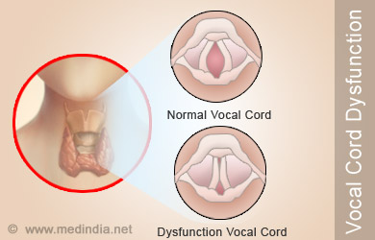

What is Vocal Cord Dysfunction?
Vocal cord dysfunction (VCD) is a condition that affects the vocal folds, commonly referred to as vocal cords, which is characterized by full or partial vocal fold closure that usually occurs during both inhalation and exhalation. This closure may cause airflow obstruction; however, it rarely results in reduction of oxygen saturation. Vocal cord dysfunction co-occurs with asthma approximately 40% of the time, but only asthma is diagnosed in many of these patients. This frequently results in a misdiagnosis of asthma. A good way to tell the difference between an asthma attack is that asthma primarily affects exhaling and VCD primarily affects inhaling. Knowing the difference between the two will help those who have both know when to use the rescue inhaler prescribed or when to use breathing recovery exercises trained by an experienced speech language pathologist.

The causes of Vocal Cord Dysfunction.
VCD “episodes” can be triggered suddenly, or come on gradually. Many different things can trigger an episode. The primary cause for VCD episode are believed to be gastroesophageal reflux disease (GERD), extra-esophageal reflux (EERD), exposure to inhaled allergens, post nasal drip, exercise, or neurological conditions that can cause difficulty inhaling only during walking. Vocal cord dysfunction is often diagnosed after all other potential conditions are ruled out.

How is Vocal Cord Dysfunction diagnosed?
The most effective way of diagnosing VCD is to perform a nasolaryngoscopy (“ scope”) during an episode. A physician can then view the movement of the vocal folds and determine whether there is any abnormality. If the endoscopy is not performed during an episode, it is likely that the vocal folds are moving normally and the clinician will not detect an abnormality. However, in severe cases, VCD is detectable outside of episode by observing persistent swelling of the vocal folds and indications of irritation. If there is an underlying condition to which vocal cord dysfunction is secondary, it is important to treat the primary condition. This alone can help control VCD.

Treatment and Management
Many People have both VCD and asthma but the treatment approach is different. For VCD it typically involves activities that relax the throat muscles including:

- Speech Therapies
- Deep Breathing Techniques

If you suffer from the seasonal allergies, asthma or GERD, managing those conditions will help in treating the VCD.
6/3/14

